Experiment 8

Pranav Garg – 2401010034

AIM: Create Sales table with the following fields (Sales No, Salesname, Branch, Salesamount, DOB)
  - Insert five records.
  - Calculate total salesamount in each branch.
  - Calculate average salesamount in each branch.
  - Display all the salesmen, DOB who are born in the month of December as day in character format i.e. 21-Dec-09.
  - Display the name and DOB of salesman in alphabetical order of the month.

Create Table
CREATE TABLE Sales (
Sales_No INT,
Salesname VARCHAR(50),
Branch VARCHAR(50),
Salesamount NUMBER(10,2),
DOB DATE
);
a) Insert 5 records
INSERT INTO Sales (SalesNo, SalesName, BranchName, SalesAmount, DateOfBirth)
VALUES
(101, 'arnav gupta', 'north', 45000, '1995-12-21'),
(102, 'sana sheikh', 'south', 32000, '1998-05-15'),
(103, 'kabir malhotra', 'north', 55000, '1996-12-09'),
(104, 'isha patel', 'east', 40000, '1997-12-05'),
(105, 'vihaan nair', 'south', 28000, '1999-08-22');

b) Total sales amount in each branch
SELECT Branch, SUM(Salesamount) AS Total_Sales
FROM Sales
GROUP BY Branch;
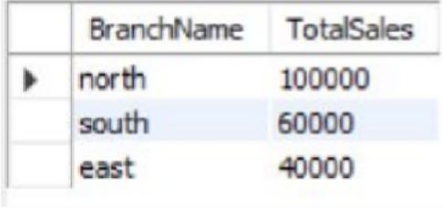

c) Average sales amount in each branch
SELECT Branch, AVG(Salesamount) AS Avg_Sales
FROM Sales
GROUP BY Branch;
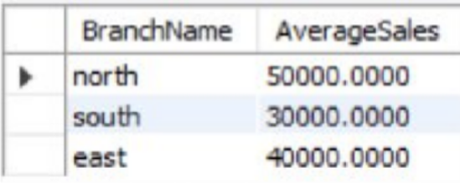

d) Salesmen born in December (formatted DOB)
SELECT Salesname,
TO_CHAR(DOB, 'DD-MON-YY') AS DOB
FROM Sales
WHERE TO_CHAR(DOB, 'MM') = '12';
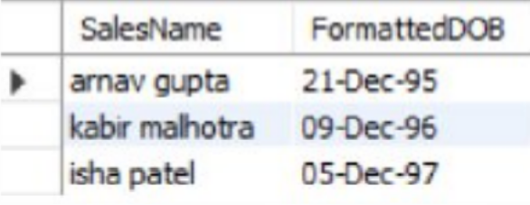

e) Order by month alphabetically
SELECT Salesname, DOB
FROM Sales
ORDER BY TO_CHAR(DOB, 'Month');
